***Гуркова Виктория* *381 группа***

***Library Database***

**Задание № 3. *Создать следующие виды запросов к базе:***

1. **Запросы с использованием различных видов соединений таблиц (Inner join, Outer join, Cross join, Cross apply, самосоединение).**

-- INNER JOIN --

SELECT b.Title, a.Full_Name AS Author_Name, a.Pseudonym

FROM Book b

INNER JOIN Author a ON b.Author_ID = a.Author_ID

Результат:

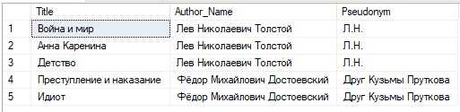

-- LEFT OUTER JOIN --

SELECT b.Title, a.Full_Name AS Author_Name

FROM Book b

LEFT OUTER JOIN Author a ON b.Author_ID = a.Author_ID

Результат:

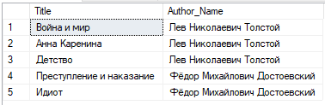

-- RIGHT OUTER JOIN --

SELECT b.Title, a.Full_Name AS Author_Name

FROM Book b

RIGHT OUTER JOIN Author a ON b.Author_ID = a.Author_ID

Результат:

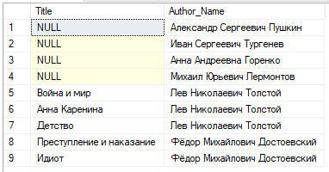

-- CROSS JOIN --

SELECT b.Title, a.Full_Name AS Author_Name

FROM Book b

CROSS JOIN Author a

Результат:

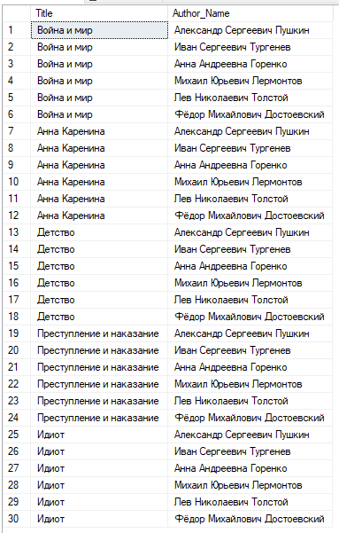

-- CROSS APPLY --

SELECT b.Title, a.Full_Name AS Author_Name

FROM Book b

CROSS APPLY Author a

Результат:

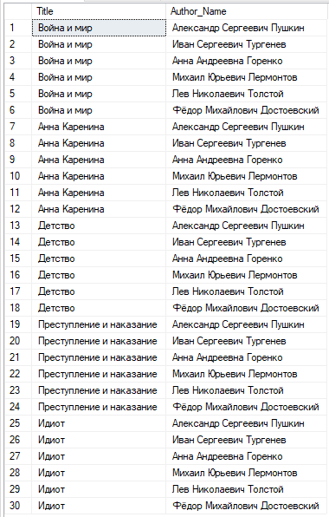

-- САМОСОЕДИНЕНИЕ --

SELECT l1.Library_ID, l1.Full_Name AS Librarian_1, l2.Full_Name AS Librarian_2

FROM Librarian l1 JOIN Librarian l2

ON l1.Library_ID = l2.Library_ID

WHERE l1.Librarian_ID <> l2.Librarian_ID

Результат:

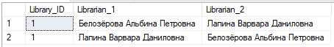

1. **Фильтрация данных в запросах с использованием предикатов (EXISTS, IN, ALL, SOME/ANY, BETWEEN, LIKE).**

-- EXISTS --

SELECT * FROM Issue WHERE Client_ID = 3 AND

EXISTS (SELECT Client_ID FROM Client)

Результат:



SELECT Title FROM Book WHERE Author_ID = 3 AND

EXISTS (SELECT Author_ID FROM Author)

Результат: результата нет, так как у автора с ID = 3 нет книг в базе



-- IN --

SELECT * FROM Book

WHERE Category_ID IN (4, 6)

Результат:

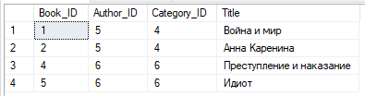

-- ANY --

SELECT Full_Name, Pseudonym FROM Author

WHERE Author_ID = ANY(SELECT Author_ID FROM Book)

--SOME --

SELECT Full_Name, Pseudonym FROM Author

WHERE Author_ID = SOME(SELECT Author_ID FROM Book)

Результат: предикаты **SOME** и **ANY** выдают одинаковый результат

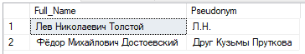

-- ALL --

SELECT * FROM Issue

WHERE Issue_Date >= ALL(SELECT Issue_Date FROM Issue)

Результат:



-- BETWEEN --

SELECT Category_ID, Category_Name FROM Category

WHERE Category_ID BETWEEN 3 AND 6

Результат:

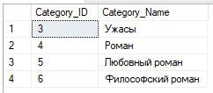

SELECT Category_ID, Category_Name FROM Category

WHERE Category_ID NOT BETWEEN 3 AND 6

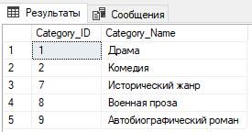

-- LIKE --

SELECT * FROM Client

WHERE Full_Name LIKE 'е%'

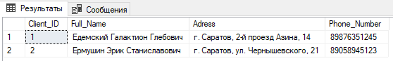

SELECT * FROM Librarian

WHERE Full_Name LIKE '%ч'

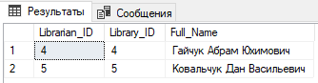

SELECT * FROM Author

WHERE Pseudonym LIKE '% % %'

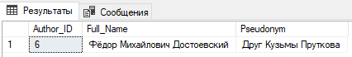

SELECT * FROM Author

WHERE Pseudonym NOT LIKE '% % %'

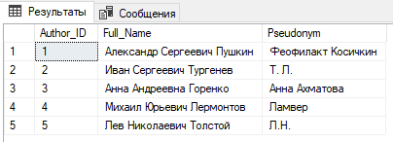

1. **Запросы с использованием выражения CASE.**

-- CASE --

SELECT Instance_ID, Publisher_ID, Year_of_Publication,

CASE

WHEN Amount_of_Page > 800 THEN 'Количество страниц больше 800'

WHEN Amount_of_Page = 800 THEN 'Количество страниц равно 800'

ELSE 'Количество страниц меньше 800'

END AS 'Количество страниц'

FROM Instance

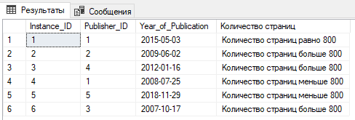

SELECT Passport_ID, Client_ID, Librarian_ID,

CASE

WHEN Issue_Date > '31.12.2019' THEN 'Выдана после 2019 года'

WHEN Issue_Date BETWEEN '01.01.2019' AND '31.12.2019' THEN 'Выдана в 2019 году'

ELSE 'Выдана до 2019 года'

END AS 'Год выдачи'

FROM Issue

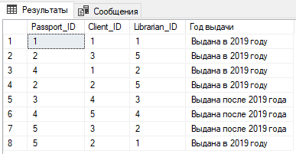

1. **Использование встроенных функций (функций преобразования типов (CAST, CONVERT), функций для проверки значений NULL**

**(ISNULL, NULLIF), COALESCE логических функций (CHOOSE,  IIF)).**

-- CAST --

SELECT Short_Name, CAST(Adress AS TEXT) AS 'Адрес'

FROM Publish_House

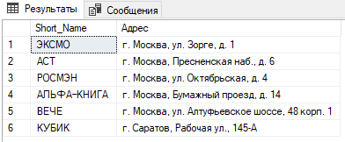

SELECT Book_ID, Condition, Amount_of_Page, CAST(Year_of_Publication AS DATETIME2)

FROM Instance WHERE Book_ID = 2

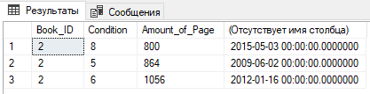

-- CONVERT --

SELECT Book_ID, Condition, Amount_of_Page,

CONVERT(VARCHAR, Year_of_Publication, 100) AS 'Дата публикации'

FROM Instance

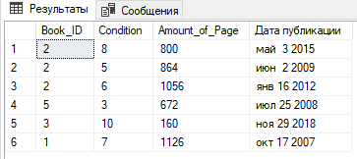

SELECT Book_ID, Condition, Amount_of_Page,

CONVERT(VARCHAR, Year_of_Publication, 101) AS 'Дата публикации'

FROM Instance

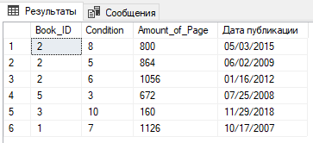

SELECT Book_ID, Condition, Amount_of_Page,

CONVERT(VARCHAR, Year_of_Publication, 112) AS 'Дата публикации'

FROM Instance

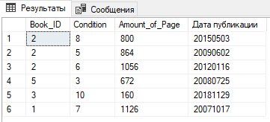

-- ISNULL --

SELECT Client_ID AS 'Клиент', ISNULL(CAST(Time_Lag AS VARCHAR(50)),

'Задержка возврата ещё не определена') AS 'Задержка возврата'

FROM Issue

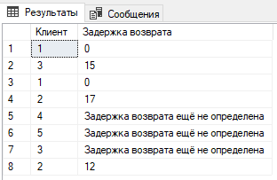

-- NULLIF --

SELECT Author_ID, Title,

NULLIF(Author_ID, 5) 'NULL если автор Л.Н.Толстой'

FROM Book

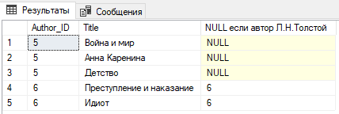

SELECT Author_ID, Title,

NULLIF(Author_ID, 1) 'NULL если автор А.С.Пушкин'

FROM Book

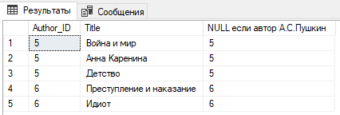

-- COALESCE --

SELECT COALESCE(CONVERT(VARCHAR(50),Actual_Return_Date,100), 'Ещё не определена') AS 'Актуальная дата возрата'

FROM Issue

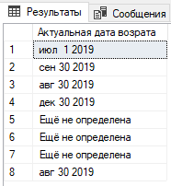

-- CHOOSE --

SELECT Client_ID, Librarian_ID, CHOOSE(Passport_ID, '1', '2', '3', '4', '5') AS 'Экземпляр книги'

FROM Issue

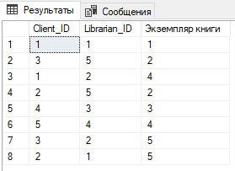

-- IIF --

SELECT Short_Name, Phone_Number, IIF(City_ID = 495, 'Москва', 'Саратов') AS 'Центральный офис'

FROM Publish_House

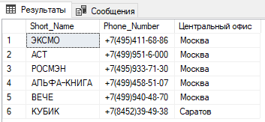

-- COALESCE and IIF--

SELECT Issue_Date, COALESCE(IIF(Time_Lag IS NULL, -1, Time_Lag), Time_Lag ) AS '-1 - книгу ещё не вернули'

FROM Issue

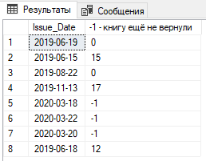

1. **Запросы с использованием функций для работы со строками (REPLACE, SUBSTRING, STUFF, STR, UNICODE, LOWER, UPPER).**

-- REPLACE --

SELECT REPLACE(Full_Name, 'А', 'О') AS 'Овторы'

FROM Author

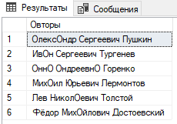

SELECT REPLACE(Full_Name, 'Библиотека', 'Читальня') AS 'Читальни'

FROM Library

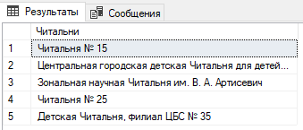

-- SUBSTRING --

SELECT Full_Name, SUBSTRING(Full_Name, 1, 1) AS 'Первая буква фамилии клиента'

FROM Client

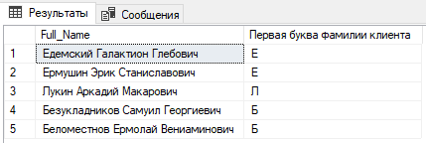

SELECT City_Name, UPPER(SUBSTRING(City_Name, LEN(City_Name), 1)) AS

'Последняя буква названия города'

FROM City

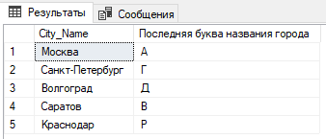

-- STUFF --

SELECT STUFF(Full_Name, LEN(Full_Name), 1, 'й хороший писатель!') AS 'Хорошие писатели'

FROM Author WHERE Author_ID >= 5

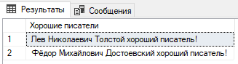

-- STR --

SELECT STR(CAST(Amount_of_Page AS FLOAT), 2, 0) FROM Instance

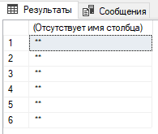

SELECT STR(CAST(Amount_of_Page AS FLOAT), 3, 0) FROM Instance

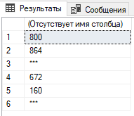

SELECT STR(CAST(Amount_of_Page AS FLOAT), 4, 0) FROM Instance

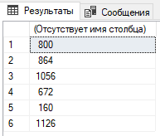

-- UNICODE --

SELECT Full_Name AS 'Authors names', SUBSTRING(Full_Name, 1, 1) AS 'First character', UNICODE(Full_Name) AS 'UNICODE Value'

FROM Author

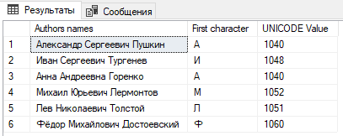

-- UPPER --

SELECT UPPER(Full_Name) AS 'Uppercase full names'

FROM Librarian

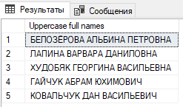

-- LOWER --

SELECT LOWER(Full_Name) AS 'Lowercase full names' FROM Librarian

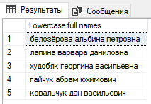

1. **Запросы с использованием функций даты и времени (DATEPART, DATEADD, DATEDIFF, GETDATE(), SYSDATE, TIMEOFFSET() и т.п.).**

-- DATEPART --

SELECT Instance_ID, Amount_of_Page, DATEPART(YEAR, Year_of_Publication) AS 'Year_of_Publication'

FROM Instance WHERE Book_ID = 2

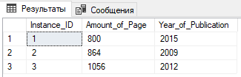

SELECT Issue_Date AS 'Дата выдачи', DATEPART(DAY, Issue_Date) AS 'Число', DATEPART(MONTH, Issue_Date) AS 'Месяц',

DATEPART(WEEK, Issue_Date) AS 'Номер недели в году', DATEPART(WEEKDAY, Issue_Date)AS 'День недели',

DATEPART(DAYOFYEAR, Issue_Date) AS 'Номер дня в году'

FROM Issue

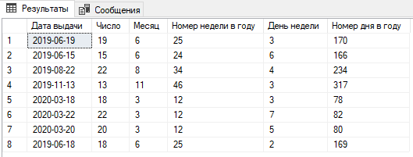

-- DATEADD --

SELECT Year_of_publication, DATEADD(YEAR, 1, Year_of_Publication) AS 'Year + 1'

FROM Instance

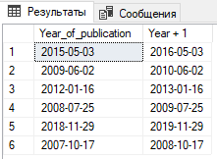

SELECT Year_of_publication, DATEADD(MONTH, 1, Year_of_Publication) AS 'Month + 1'

FROM Instance

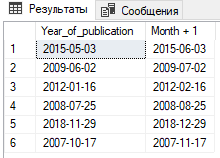

SELECT Year_of_publication, DATEADD(DAY, 1, Year_of_Publication) AS 'Day + 1'

FROM Instance

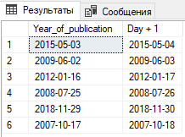

-- DATEDIFF --

SELECT Year_of_Publication AS 'Год издания',

DATEDIFF(YEAR, Year_of_Publication, '01.01.2020') AS 'Сколько лет изданию',

DATEDIFF(MONTH, Year_of_Publication, '01.01.2020') AS 'Сколько месяцев изданию',

DATEDIFF(DAY, Year_of_Publication, '01.01.2020') AS 'Сколько дней изданию'

FROM Instance

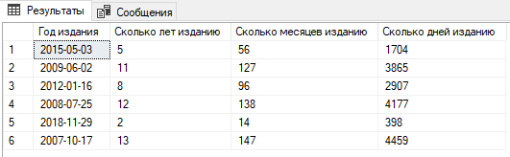

SELECT SYSDATETIME() AS 'SYSDATETIME',

SYSDATETIMEOFFSET() AS 'SYSDATETIMEOFFSET'

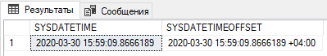

SELECT SYSUTCDATETIME() AS 'SYSUTCDATETIME',

CURRENT_TIMESTAMP AS 'CURRENT_TIMESTAMP',

GETDATE() AS 'GETDATE', GETUTCDATE() AS 'GETUTCDATE'

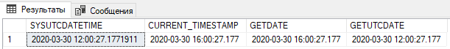

1. **Запросы с использованием агрегатных функций, группировок (GROUP BY) и фильтрации групп (HAVING).**

-- Агрегатные функции --

SELECT SUM(Amount_of_Page) AS 'Количество страниц в трёх экземплярах "Анны Карениной"'

FROM Instance WHERE Book_ID = 2

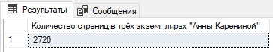

SELECT AVG(Time_Lag) AS 'Средняя длительность задержки возврата'

FROM Issue

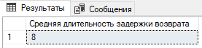

SELECT AVG(Condition) AS 'Среднее состояние книг в библиотеке'

FROM Instance

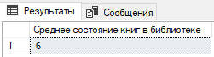

SELECT MAX(Time_Lag) AS 'Максимальная задержка возврата'

FROM Issue

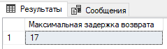

SELECT MIN(Amount_of_Page) AS 'Наименьшее количество страниц в издании "Анны Карениной"'

FROM Instance WHERE Book_ID = 2

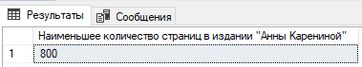

SELECT COUNT(Instance_ID) AS 'Количество экземпляров книг в библиотеке'

FROM Instance

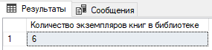

SELECT COUNT(*) AS 'Количество записей о выдаче'

FROM Issue

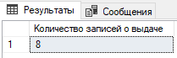

-- GROUP BY --

SELECT Client_ID AS 'Клиент', COUNT(Issue_ID) AS 'Количество выдач клиенту'

FROM Issue

GROUP BY Client_ID

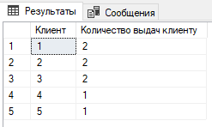

SELECT Librarian_ID AS 'Библиотекарь', COUNT(Issue_ID) AS

'Количество выдач библиотекарем'

FROM Issue

GROUP BY Librarian_ID

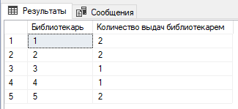

SELECT Author_ID AS 'Автор', COUNT(Book_ID) AS 'Количество книг автора'

FROM Book

GROUP BY Author_ID

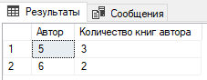

-- HAVING --

SELECT Author_ID AS 'Автор', COUNT(Book_ID) AS 'Количество книг автора'

FROM Book

GROUP BY Author_ID

HAVING COUNT(Book_ID) > 2

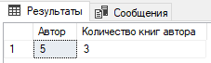

SELECT Book_ID, COUNT(Instance_ID) AS 'Количество экземпляров', AVG(Condition) AS 'Среднее состояние её экземпляро'

FROM Instance

GROUP BY Book_ID

HAVING AVG(Condition) > 6

